

**A REPORT FOR PROJECT ON**

**"COURIER MANAGEMENT SYSTEM"**

IN THE PARTIAL FULFILLMENT OF THE REQUIREMENT FOR

DEGREE OF

MASTERS OF COMPUTER APPLICATIONS

(SEMESTER III)

**SUBMITTED BY:-**

Name. Taher Ali Name: Swapneel Shubham

Roll No.71 Roll No.70

Name: Ritu Verma Name: Chandra Shekhar

Roll No.76 Roll No.50

**SUBMITTED TO**

BHARATI VIDYAPEETH

(DEEMED TO BE UNIVERSITY)

INSTITUTE OF MANAGEMENT AND ENTREPRENEURSHIP DEVELOPMENT

Erandwane, Pune – 411038



**Certificate of Completion**

This is to certify that **Taher Ali(71), Swapneel Shubham(70), Ritu Verma(76), Chandra Shekhar(50)**, are bona-fide student studying in Semester-III of Master of Computer Application (MCA) degree program of Bharati Vidyapeeth (Deemed to be University) ,Pune for the year **2018-2019.**

As a part of University curriculum they have successfully completed a minor software project titled as **"Courier Management System"** under the guidance of **"Prof. Shweta Joglekar".**

This fulfils the requirement of University course module of Semester-III.

**PROJECT GUIDE**

**(Prof. Shweta Joglekar)**

**Programme Director MCA**

**(Dr. Nilesh Mahajan)**

**I/C DIRECTOR - MCA**

**(Dr.Ajit More)**



**ACKNOWLEDGEMENT**

Making the following acknowledgement is not a mere formality but a way to express my sincere thanks to the people who were instrumental in presenting the project report.

Firstly we express our boundless sense of gratitude to our guide **"Prof. Shweta Joglekar"** for allowing us to work in this area.

We express our deep sense of gratitude to **"Prof. Shweta Joglekar"** for her keen interest and efficient guidance in project work. She is the person conceived the idea of the project, and inspiring to complete this task, without which this could not have seen in the light of the day.

Cordial thanks and heartfelt obligations to **"Prof. Shweta Joglekar"** for her guidance and valuable contribution during project work.

**Team Members: -** Name: Taher Ali(71)

Name: Swapneel Shubham(70)

Name: Ritu Verma(76)

Name: Chandra Shekhar(50)

**Index**

1. **Introduction**
   * + - * Introduction to system
         * Scope of the system
         * Proposed System
2. **REQUIREMENT ANALYSIS & SPECIFICATION**

* Requirement Elicitation
* Requirement Analysis & Investigation
* General Requirements

1. **Analysis**
   * + - * Fact Finding Technique
         * Feasibility Study
2. **Methodology Used**
3. **System Requirements**
   * + - * Hardware & Software Requirement
4. **System Design**
   * + - * Use-case Diagram
         * E-R Diagram
         * Context Level Diagram
         * Data Flow Diagram
         * File Design
         * Activity Diagram
5. **Form Design**
6. **Reports**
7. **Advantages & Limitations**

**10. Future Enhancement**

**11. Bibliography**

**Introduction**

This project is a demonstration of a data connectivity application.

In data connectivity, user interface and the data storage are separated and handled by different application.

The frontend of the project is Html, CSS (Cascading Style Sheet) and JavaScript is a very simple platform that offers a powerful GUI (**Graphical user interface**).

It offers wide range of controls to help the developers to design an interactive application.

Backend application employed for the project is MySQL, It is widely used in the modern industries and very flexible compared to other databases.

It avoids boiler plate code thereby providing templates for every database interfaces and so on.

“Courier Management System” is a comprehensive system which

Handles records of operations, Posts, Calculate Post amount, and many more. Consignments and posts details for Sending and tracking, Postage calculation and insurance for consignments .Consignment and posts details are made simply to access via creation of reports. As well as this system maintain the details of speed post transactions register post transaction there by eliminating the manual long work.

**Existing System**

* In earlier system, all the activities of the typical Courier Management systems were carried out manually.
* Record Of transactions, complaints, consignment and posts details, Customer details, Employee details, insurance details and other details and payroll were done on hard paper.
* As a result, the system proved to be very much time consuming

And costlier and also it lacked efficient report generation.

* The overall existing system is incapable of completing in the modern world markets.
* In previous there was no insurance facility available for consignments, no postage calculator available for calculating amount for consignments and posts according to its weight, height and length and according to its destination.
* The overall efficiency of this system is more reliable than the previous system in terms of database coordination with the frontend application.

**Scope**

**Goal:** The aim of this project is to create a comprehensive Courier management system using data connectivity tools to efficiently handle the business and generating analysis reports

* Functions:

1. Maintaining Consignment and posts details, such as adding new consignments and posts for sending to its destination and deletion of details after receiving of the consignment to its owner or cancelling the consignments.
2. Keeping a track of consignments and posts, Delivery details and also which Courier Executive is handling those consignments and posts.
3. Consignments Insurance for customer satisfaction and for consignments safety.
4. Authentication for user login and provides access to system rights for create, update and modify system databases.

* The system will be a “*Standalone Web Application”* and not an online.
* There will be 4 users for the system that will have system privileges.
* Tables Required To be employed in the MySQL for the system:

**Proposed System**

* **Description:-**

The Proposed of system is a computer web application for the “*Courier Management system”* where informational data is stored and manipulated. It deals with the entities like employees, customer sender, customer receiver and so on.

* **Registers:-**

There is no need to maintain huge visitors. As the system carries all its operational in a computer, the need physical registers is eliminated.

* **Speed and accuracy:-**

The transactions speed is enhanced by the use of simple and powerful GUI (graphical user interface) and avoiding chances of human failure in typing.

* **Manpower:-**

The New proposed system needs less manpower work and less people can do the large stuff of work in efficient manner.

* **Efficiency:-**

Saves the data entry time and cost of manpower and work tremendous calculation in just a second.

* **Past Details:-**

The Proposed system which contains the details of every record involved in the system in the beginning. It is a type of system in which you can extract the record of the past to the beginning and also to make the updating easily and in an efficient manner.

* **Reduce Redundancy:-**

One of the most Important feature of this system is that its reduce the redundancy of this system is that it reduce the redundancy of the data and some recording were made in the earlier in this book and thereby the books become looked mercy.

**Feasibility Study**

Feasibility study is an analysis and evaluation of proposed project to determine if it :

* is technically feasible?
* is feasible within the estimated cost?
* will it be profitable?

The feasibility study is an evaluation and analysis of the proposed project which is based on extensive investigation and research to support the process of decision making. Feasibility study is the process of determination of whether a project is worth doingor not.

* **Technical Feasibility:**

Technical study is the analysis and diagnosis of technical component requirement, the availability and the equivalent regarding it.

**Queries:**

1. What are my hardware and these software requirements?

2. Is my current hardware is compatible with the latest or advanced system software.

3. Is the current technical workforce is capable to handle and operate the system software in an efficient manner.

4. Is the technical components or resources are available?

5. Does the system have efficient security?

* **Operational feasibility:**

1. Is this software is compatible for and GUI **(Graphical user interface)** system or console based web application.

2. Is this system is supporting multiple languages

3. Is it user-friendly?

4. “Does it support multi- user or is it a standalone web application”.

* **Economic Feasibility :-**

Economic analysis is most frequently used for evaluation of effectiveness of the system. More commonly known as cost/ benefit analysis the procedure is to determine the benefit and saving that are expected from a system and compare them with the costs, decisions is made to design and implement the system A simple economic analysis that bound to be associated with the project of this kind. A economic analysis that gives the actual comparison of costs and benefits is much more meaningful in such cases. In the system, the organization is most satisfied by economic feasibility because if the organization implements the system, it need not require any additional hardware resources as well as be saving a lot of time. It is highly required system that provides the feasibility to maintain record. Also it is possible to implement within the available resource, time and no extra training required to resources.

**REQUIREMENT ELICITATION & SPECIFICATION**

* **Requirement Elicitation**

Requirement elicitation is one of the most critical, error prone and most communication intensive aspect of software development. It is an activity that helps to understand the problem to be solved. After receiving the problem statement the next step is to gather all the possible requirements according to the user. Its main goal is to find what user really need. It bridges the gap between user and developer. There are many requirement elicitation techniques like brainstorming, workshops, interviews, survey etc.

* **Requirement Analysis & Investigation**

Requirement analysis is an activity during which the requirements gathered during the elicitation phase are analyzed for conflicts, ambiguity, inconsistencies and missing requirements. The requirement engineer must remove these conflicts through the process of negotiation. Users are asked to rank requirements and then discuss conflicts in priority. Risk associated with each other requirements are identified and analyzed. Using an iterative approach requirement are eliminated or modified so that each party achieves some measures of satisfaction.

User requirements should be written in natural language so that any non- technical person can also understand the requirements but for un-ambiguity we need system models. System models generally represents requirements in graphical form.

## General Requirements

Courier Management System is having many modules, which make the software more efficient and user friendly. The modules make the maintenance of the database easier. The different modules in this project are described below

* + - Feedback
    - Shipments
    - Courier Officers
    - Shipment Track
    - Courier Offices

**Fact Finding Techniques**

For the "Courier Management System", the following techniques were employed.

1. Observation
2. Interviews
3. Questionnaire
4. Record review

**1. Observation**:   
  
Our analyst wanted to see the functioning of Courier Management System. So, analyst visited the Courier Office for two days and observed the master admin who is arranging the Shipment and Consignments. The analyst also inspected the place where the records are stored and from that it was seen that it was real mess, also he finds that how people were waiting to send the shipment and waiting in a long queue. To see if a particular Shipment And consignment receipt is already issued, it is a difficult and effort intensive process. From site visit our analyst had a good understanding of the functioning of the system. After this, the analyst performed some personal interviews of us Department staff and few members. In the next section we'll look at these interviews. 

**2. Interviews:**  
Interviews are useful to gather information from individuals. Given below is the interview between the analyst and one of the librarians, during the information gathering stage of the development of our library system.   
  
Analyst: Hi, I have come to talk to you regarding the Functioning of your Courier Office Management System.   
  
Office Manager: Hello, do come in. I was expecting you. 

Analyst: I'll come straight to the point. Don't hesitate; you can be as much open you wanted to. There are no restrictions.   
  
Office Manager: I'll give you my whole contribution   
  
Analyst: Tell me are you excited about the idea of having an automated system for your Courier Office system?   
  
Office Manager: Yes, I do. Very much. After all its going to reduce our loads of work.

Office Manager: Will you elaborate on it?   
  
Office Manager: Major problem is managing the records. There are so many of them. Many times, our record will have lost. Then we have to issue a duplicate Receipt for it. But there is a flaw in it. It is difficult to find out if it is genuinely the case. Member can lie about it so that he/she claim the insurance of their consignment or shipment. And we can't do anything about it.   
  
Analyst: What do you think be ideal solution to this? 

Office Manager: There should be no paper record at all. All the information should be put into computer. It'll be easy for us to check how many Receipts we have already to a particular member.   
  
Analyst: How often you get new members?   
  
Office Manager: Very often. At about 20 to 50 members in a day, due to this we store tremendous and large amount of data in the form of paper, due to because it is already very difficult to manage and manipulate the record. But if this whole system gets computerized then we'll open the membership terms. From this system, the management hopes to earn huge   
revenues.

Analyst: Do you keep records of Customer Sender and Customer Receiver?

Office Manager: Yes.

Analyst: Do you want facility of keeping records of customer sender and customer receiver in database?   
  
Office Manager: Yes, we want type of such facility, so that we have all the information of our regular customer and we can fill it instantly without keeping them wait in a long queue.   
  
Analyst: How do your categories your Consignments?

Office Manager: By three types which is mail, parcel, miscellaneous (stamp, others) which was in a unique form.

Analyst: Would you prefer registration for users rather than the printed form?   
  
Office Manager: Yes, we really would. Sometimes we lose these forms then we don't have any Information about that particular customer. It will be better to have it on computer.   
  
Analyst: Do you have any other expectation or suggestion for the new system?

Office Manager: It should be able to produce reports faster.   
  
Analyst: Reports? I completely forgot about them. What reports you people produce presently?   
  
Office Manager: Well first is for Daily Consignment in the Office Received at the end of the day. Another for Shipment listing, one for our Customer sender, and reports for Customer Receiver and last but not the least is feedback records. 

Analyst: Do you have some format for them?

Office Manager: Yes, we do have and we Want that the same format be used by the new system.

Analyst: Yes, we'll take care of that,

**3. Questionnaires:**

The questionnaire is for office staff

Instructions: Answer as Specified by the format. Put NA for non-applicable situation.

**1. What are your expectations out of the new system (computer based)? Rate the following on a scale of 1-4 giving a low value for low priority.**

a) Better cataloguing

b) Better managing of users

c) Better shipment and consignment management

d) Computer awareness

e) Any other

**2. How many users are you expecting?**

**3. How many consignment are received in one office (Approx)?**

**4. How you want the Consignment and shipment to be categorized for searching (like by Consignment Id or shipment id, customer name or by phone-number)?**

**5. Is there any difference in the roles (privileges) of two members?**

Yes\No Please specify if Yes

**6. Do you want facility of Courier Office Id in advance?**

Yes\No

**7. Do you have data of all the tables entered into some kind of database?** Yes\No

**8. How do you want users to be categorized?**

**9 Would you like registration for users rather than printed form?**

Yes/No

**4. Record Review**

Based on review of all the books of Courier Management system, it was understood that there were many errors in the records which was maintained in the books or paper works.

**METHODOLOGY USED**

* ITERATIVE AND INCREMENTAL MODEL

### Image result for incremental model

Incremental Model is a process of software development where requirements divided into multiple standalone modules of the software development cycle. In this model, each module goes through the requirements, design, implementation and testing phases. Every subsequent release of the module adds function to the previous release. The process continues until the complete system achieved.

### The various phases of incremental model are as follows:

**1. Requirement analysis:** In the first phase of the incremental model, the product analysis expertise identifies the requirements. And the system functional requirements are understood by the requirement analysis team. To develop the software under the incremental model, this phase performs a crucial role.

**2. Design & Development:** In this phase of Incremental model of SDLC, the design of the system functionality and the development method are finished with success. When software develops new practicality, the incremental model uses style and development phase.

**3. Testing:** In the incremental model, the testing phase checks the performance of each existing function as well as additional functionality. In the testing phase, the various method is used to test the behavior of each task.

**4. Implementation:** Implementation phase enables the coding phase of the development system. It involves the final coding that design in the designing and development phase and tests the functionality in the testing phase. After completion of this phase, the number of the product working is enhanced and upgraded up to the final system product

## Advantage of Incremental Model:

* Errors are easy to be recognized.
* Easier to test and debug
* More flexible.
* Simple to manage risk because it handled during its iteration.
* The Client gets important functionality early.

## Disadvantage of Incremental Model:

* Need for good planning.
* Total Cost is high.
* Well defined module interfaces are needed.

**Hardware And Software Requirements**

**HARDWARE**

**1) Processor: 32-bit, Intel-Pentium, 2.5 GHz minimum per core (If your dataset size is significantly larger than the medium dataset, we recommend 8 cores).**

**2) Processor Speed: 1.25 hitter or above.**

**3) RAM: 2 GB minimum.**

**4) HDD capacity: 1024 Mb minimum.**

**5) Monitor**

**6) Keyboard**

**7) Mouse**

**SOFTWARE**

**1)Operating System: Windows XP and above.**

**2)Front-End application: HTML and Css.**

**3)Back-End application: PHP and Java Script and MySQL.**

**4) Xampp,Wamp Server**

**5)Notepad++, ATOM**

**System Design**

**Use-Case Diagram**

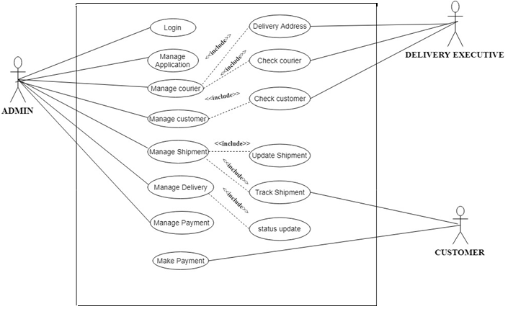

**ER-Diagram**

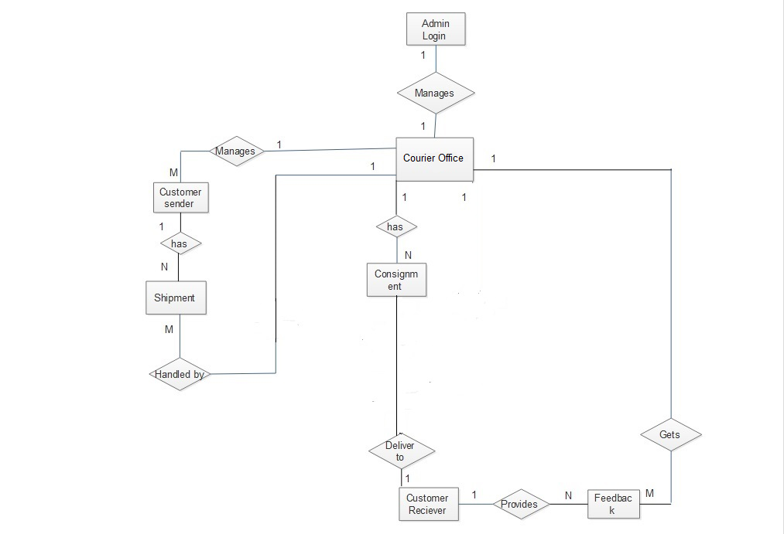

**Context Level Diagram (CLD)**

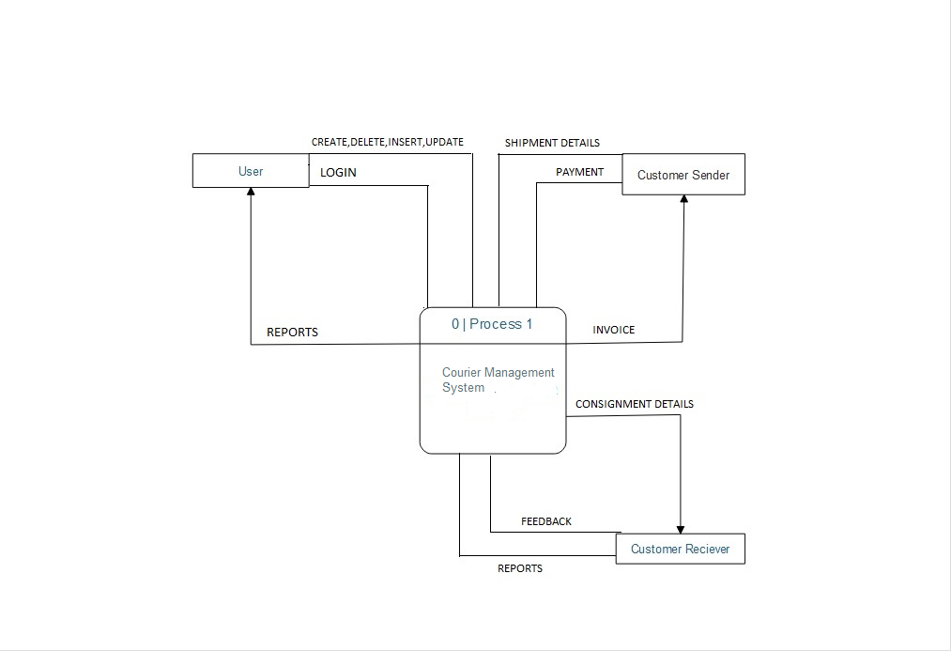

**Data Flow Diagram(DFD)**

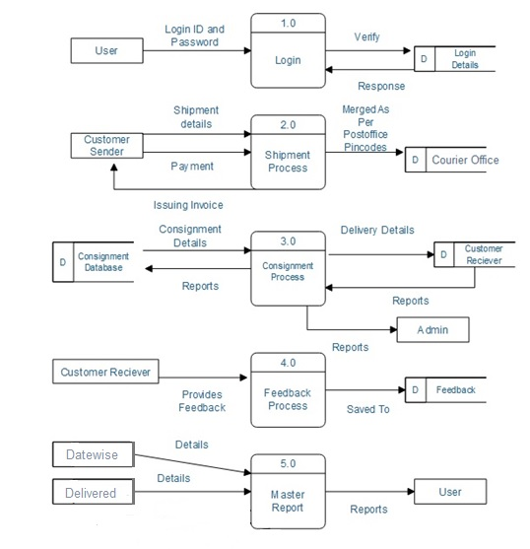

**File Design**

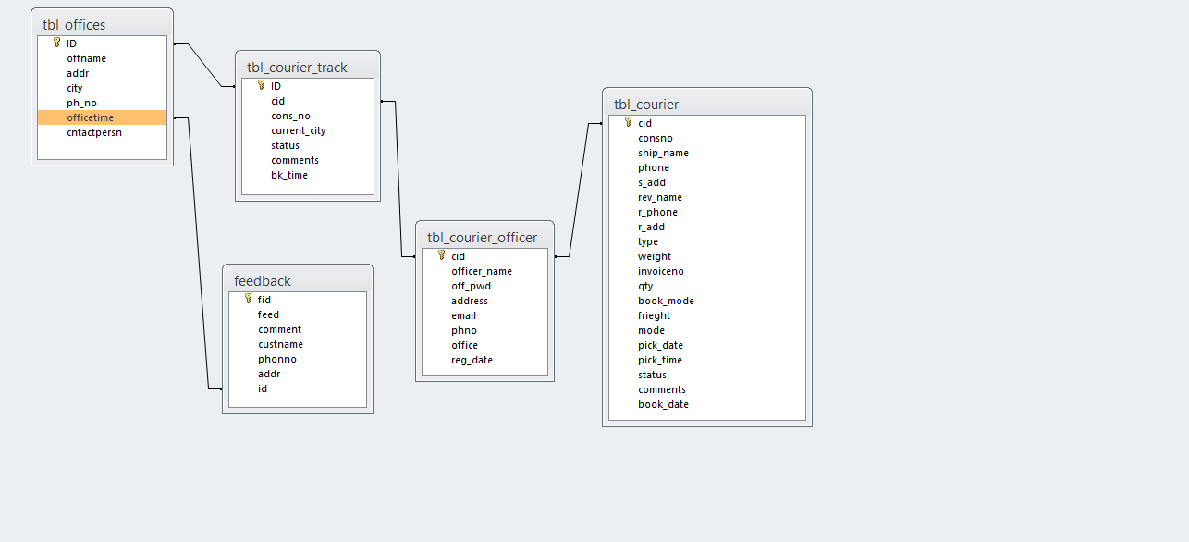

**ACTIVITY DIAGRAM**

* LOGIN

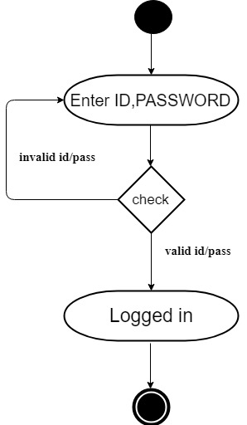

ADD COURIER

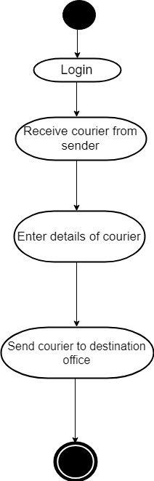

* RECEIVE ITEM

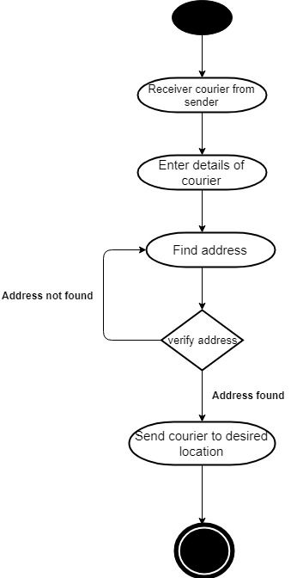

* TRACK

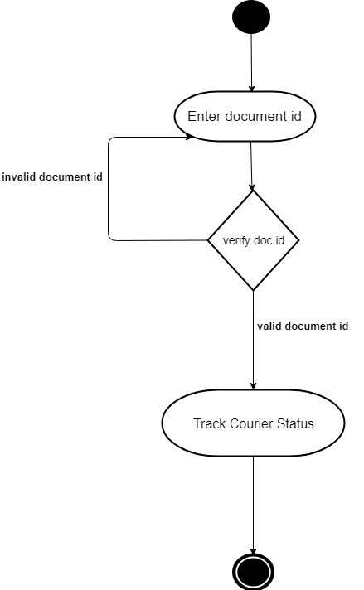

* ADD MANAGER

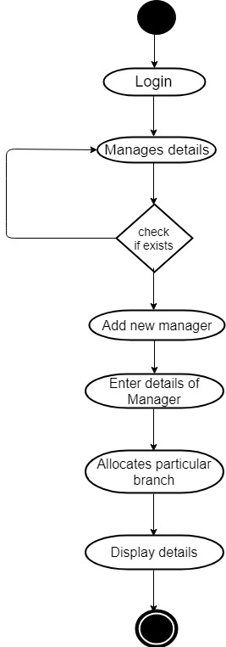

* FEEDBACK

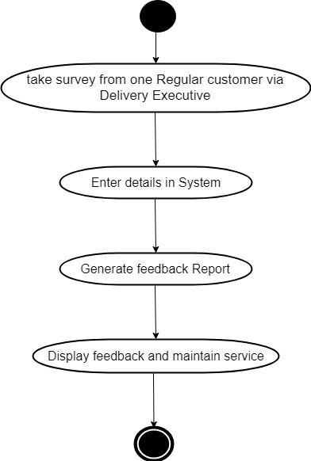

**Database Design**

* **Table Offices:**

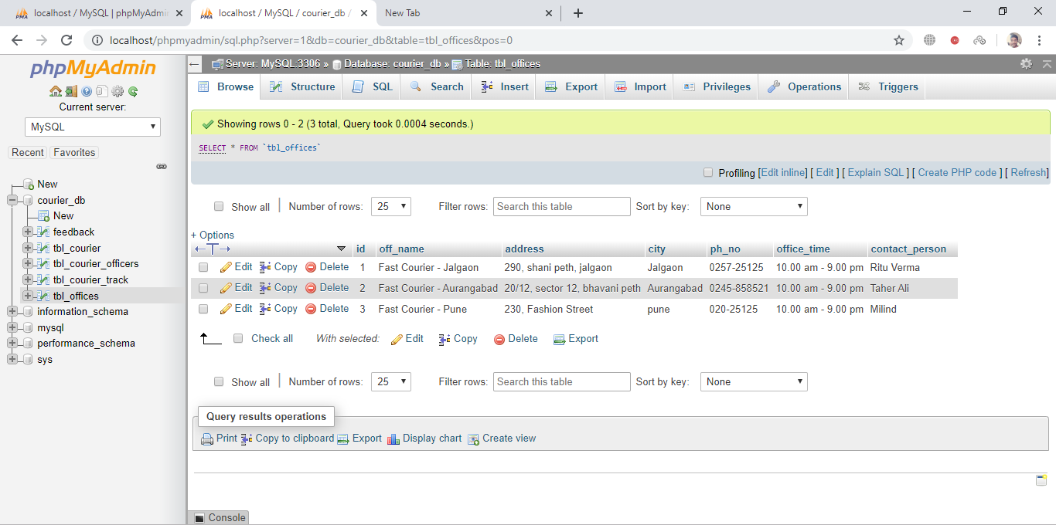

* **Table Courier**

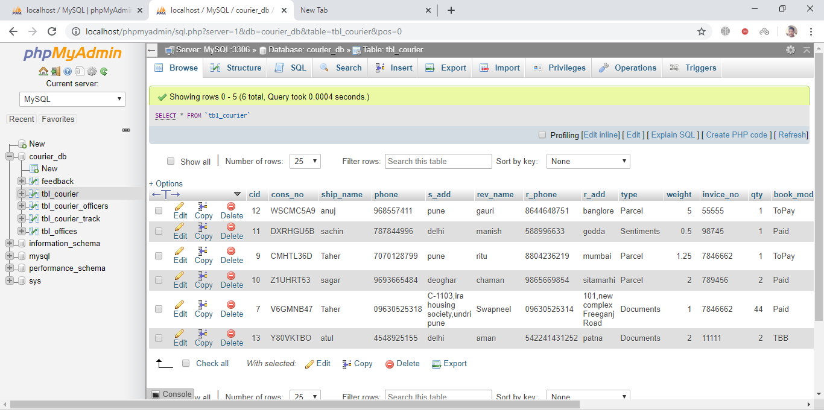

* **Table Officers**

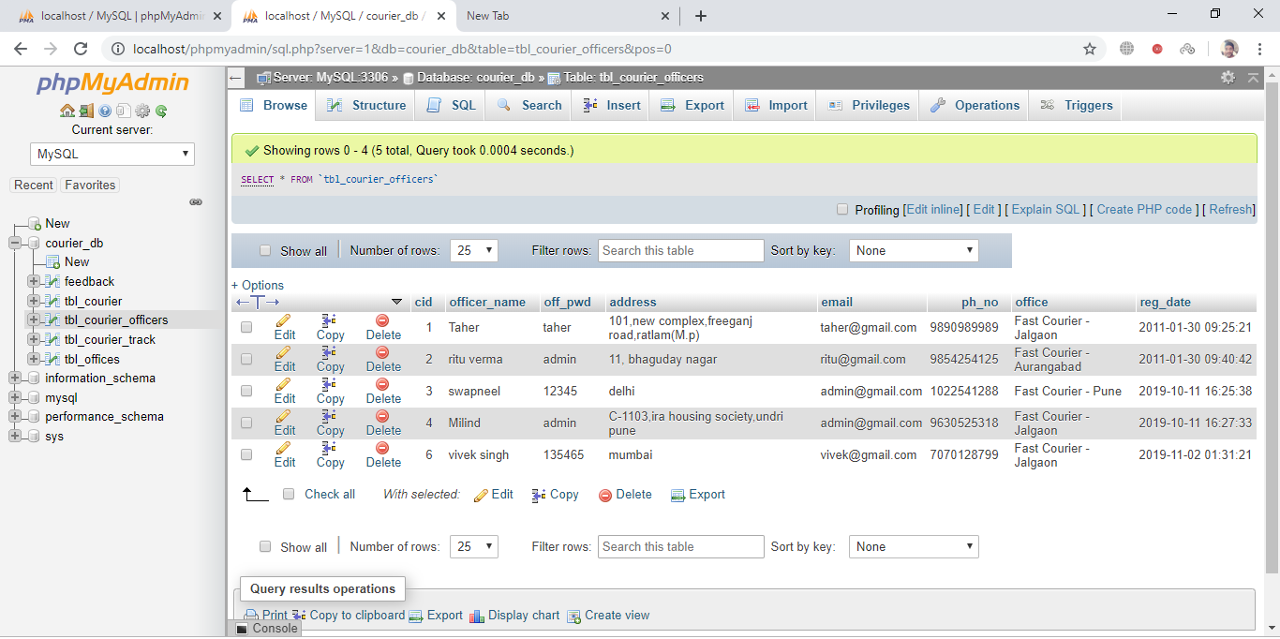

* **Table CourierTrack**

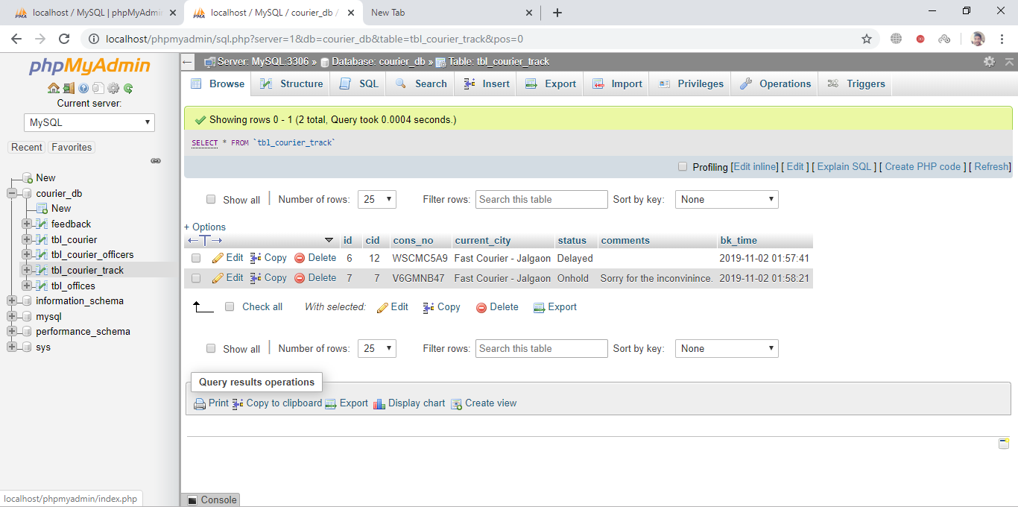

* **Table Feedback**

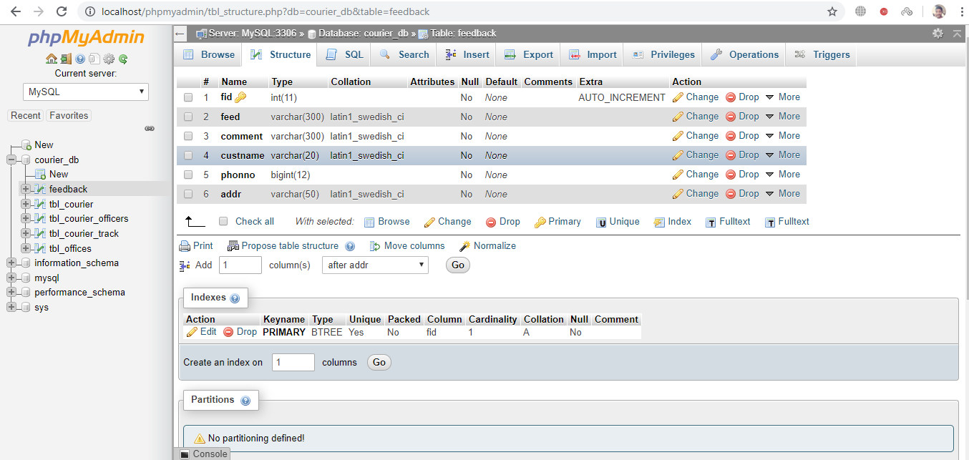

**Page Design**

**Index**

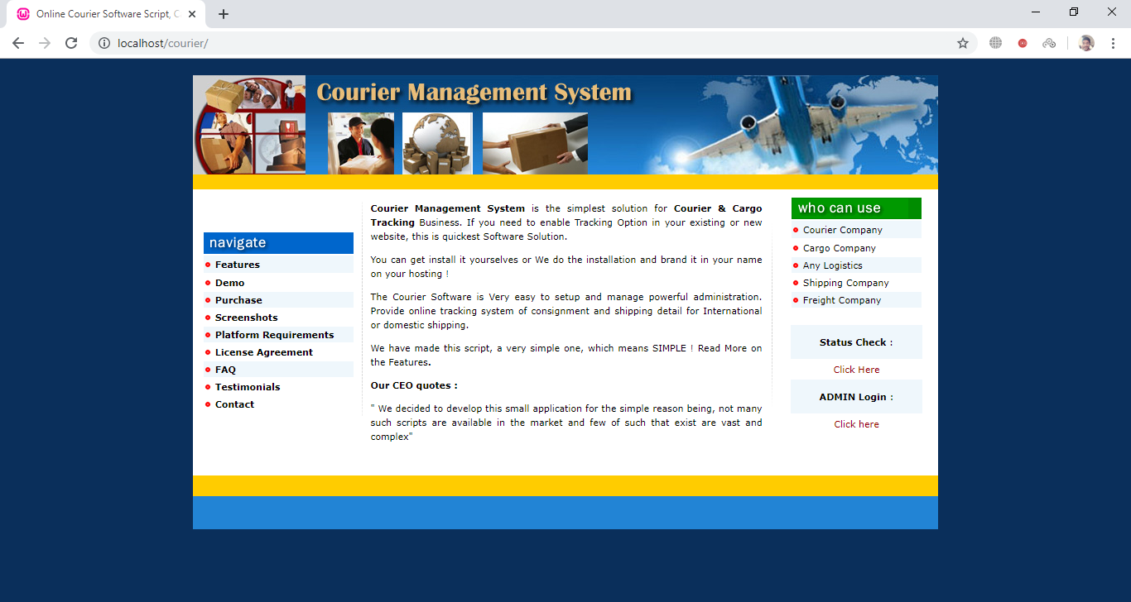

**Login**

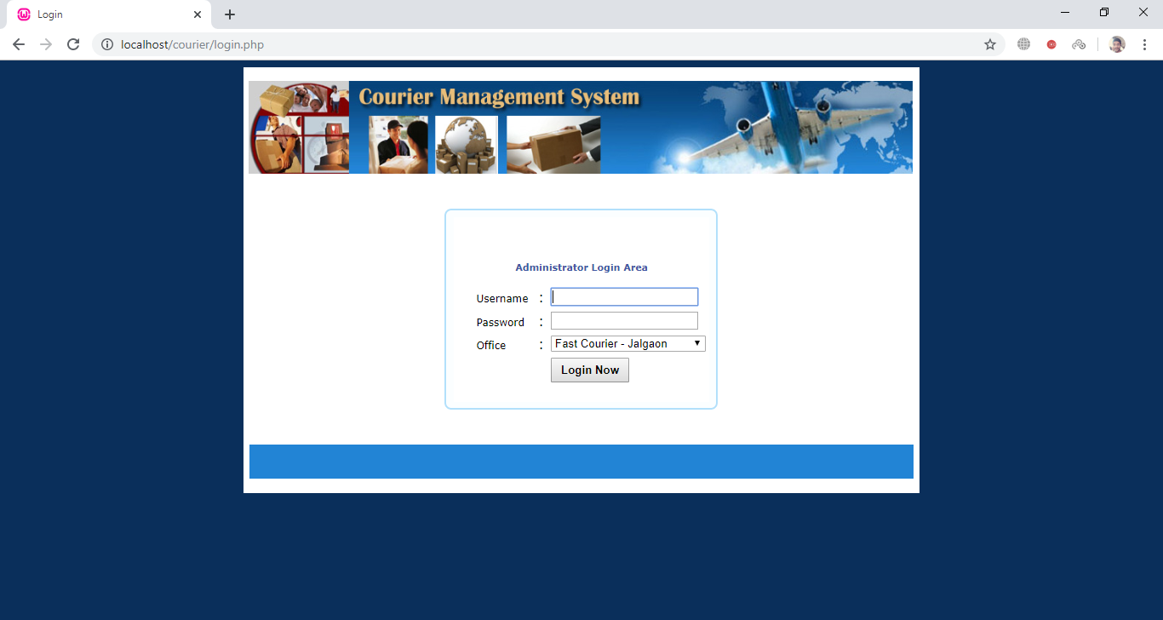

**Admin**

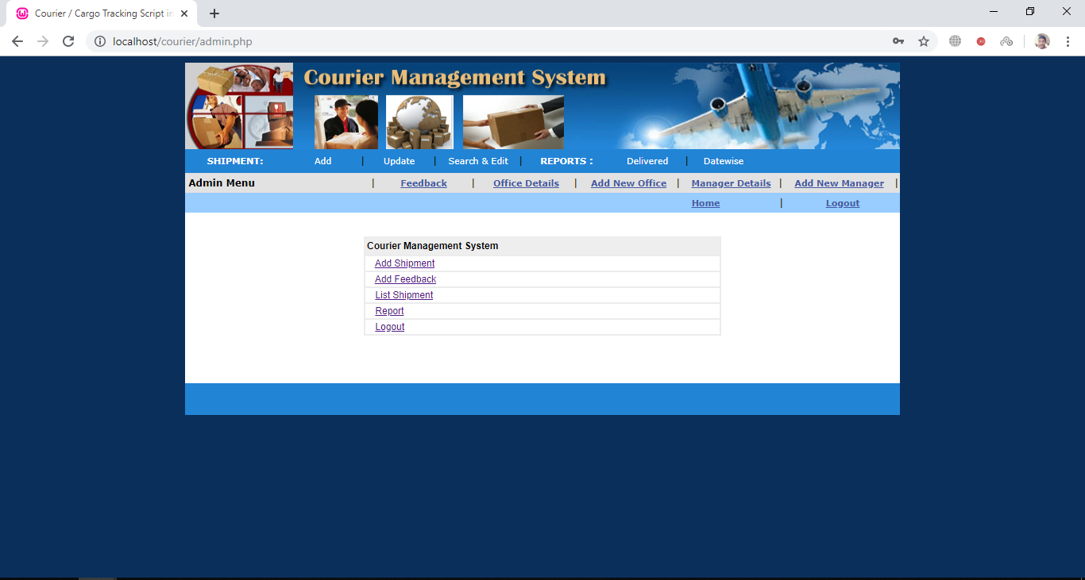

**Add Shipment**

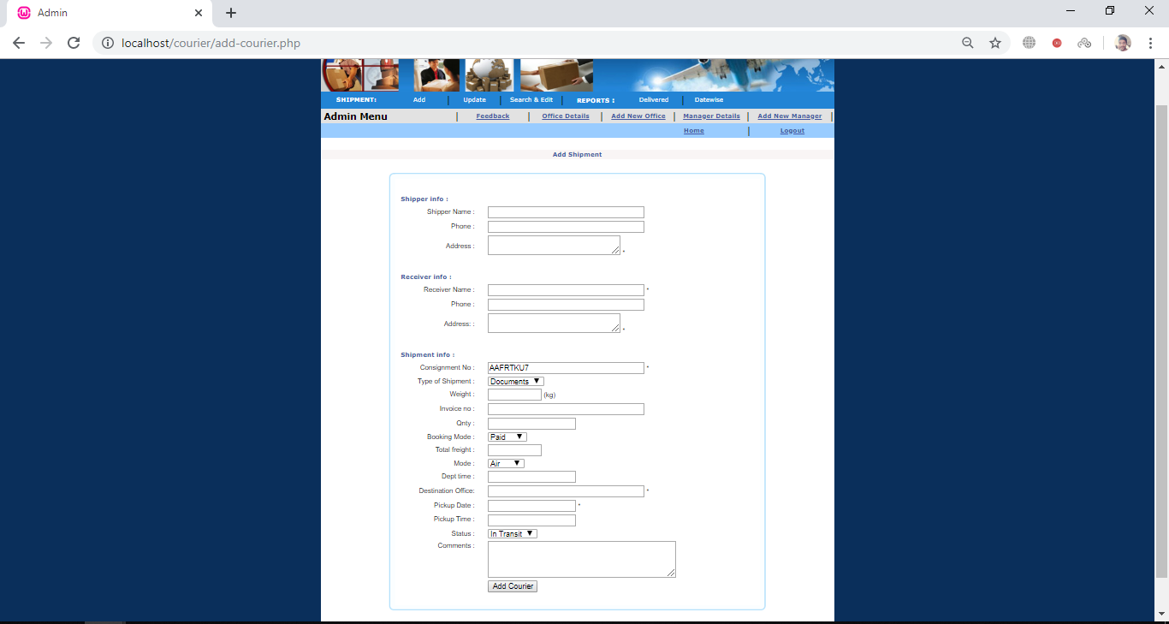

**Track Shipment**

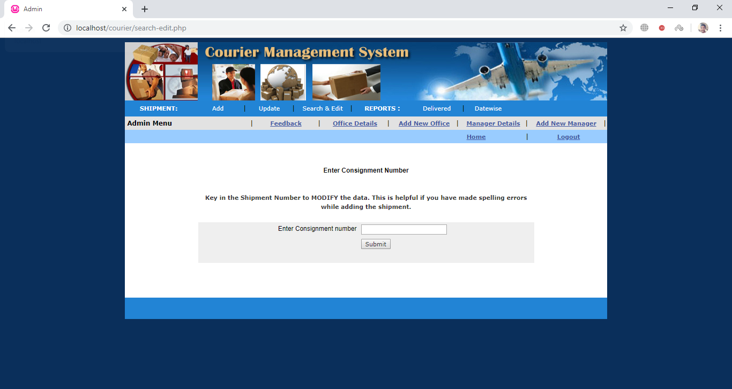

**Update Shipment**

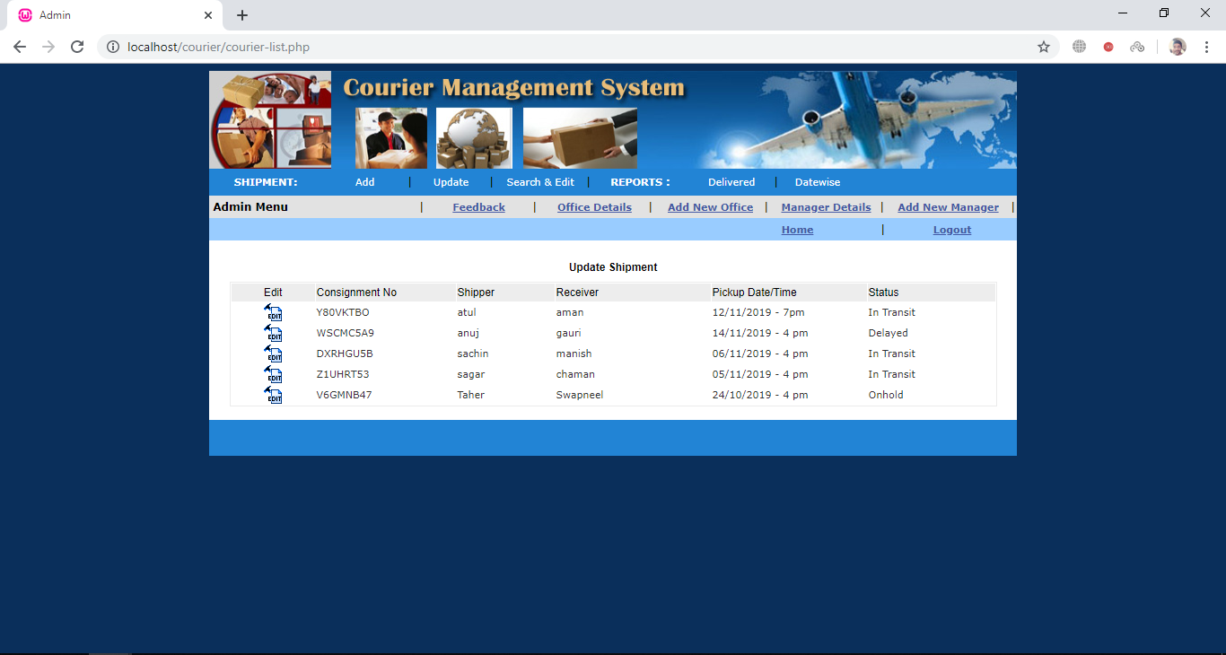

**Add New Office Manager**

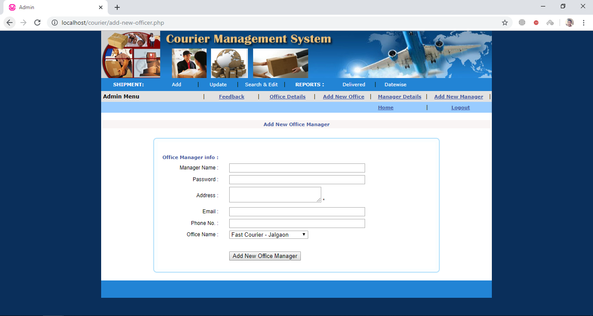

**Manager Display Details**

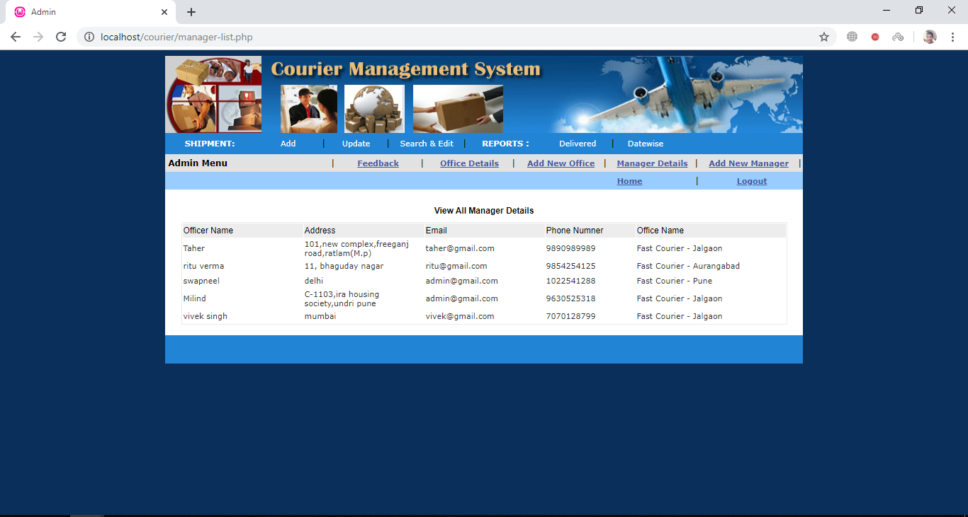

**Add New Office**

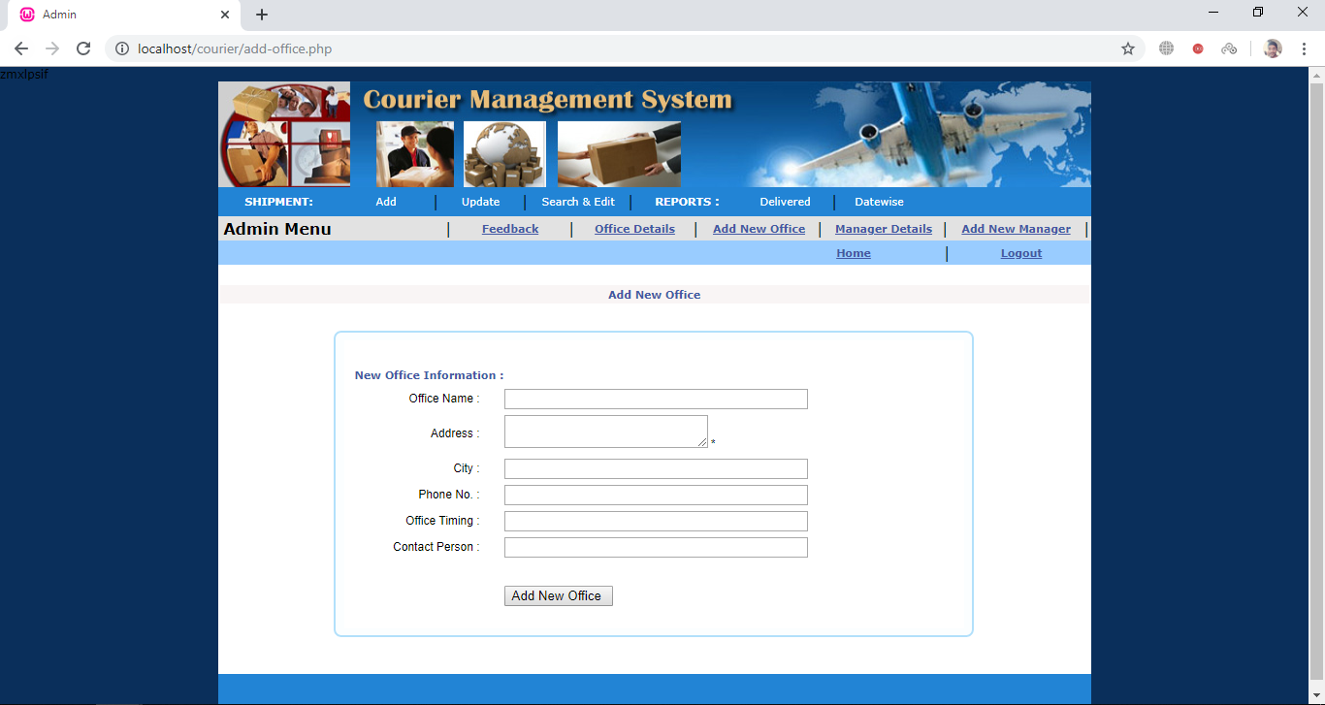

**Display Office Details**

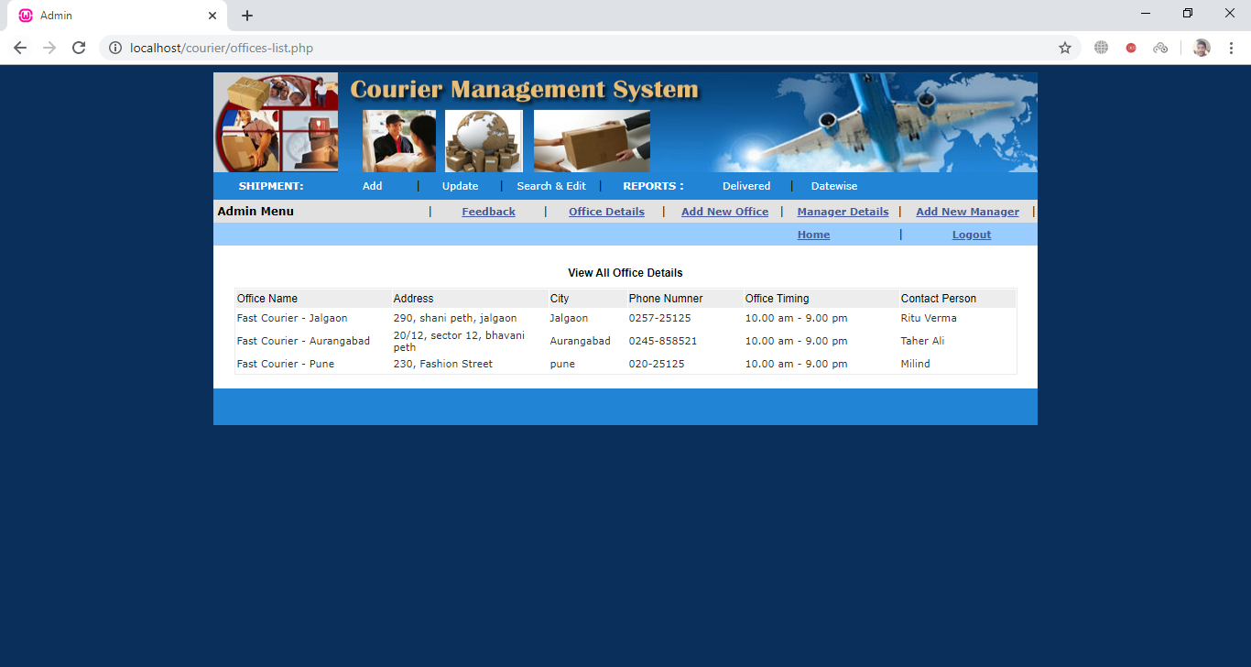

**Feedback**

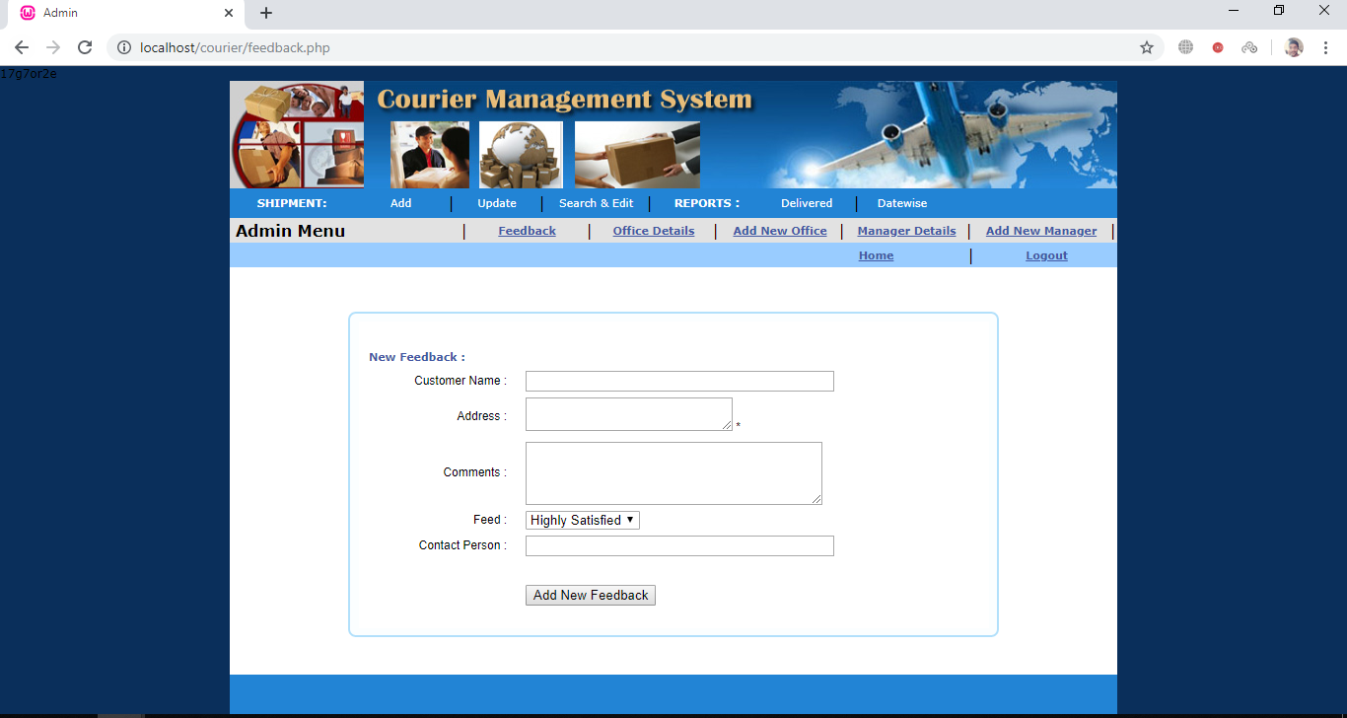

**Display Feedback**

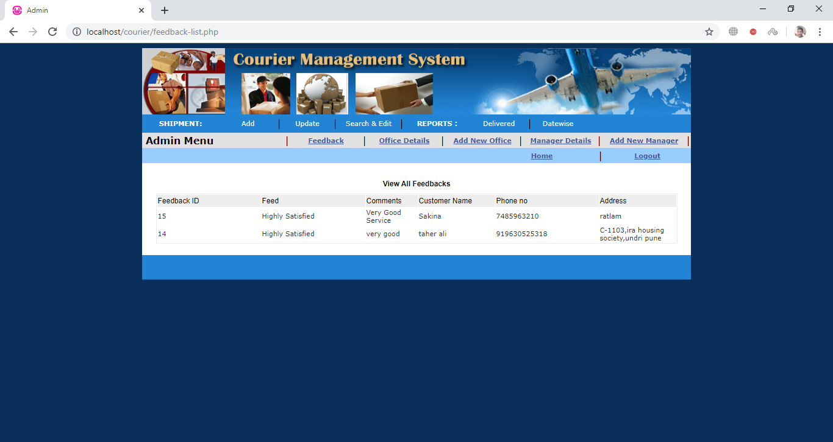

**Reports Generation**

**Date wise Report**

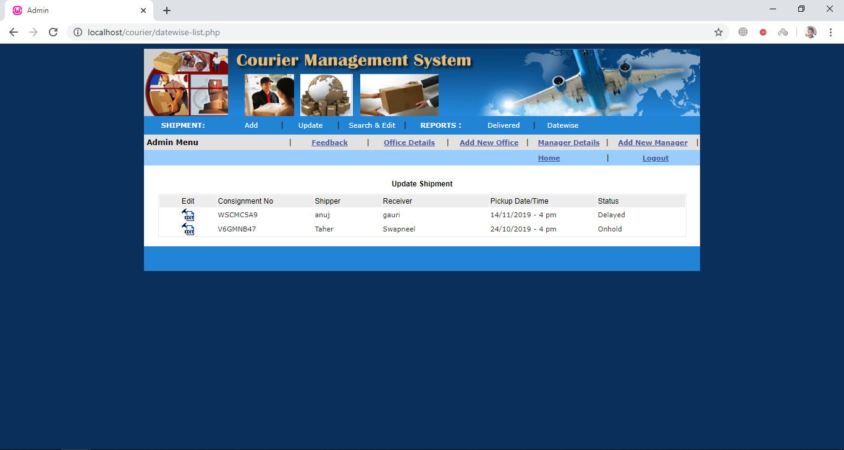

**Delivery Wise Report**

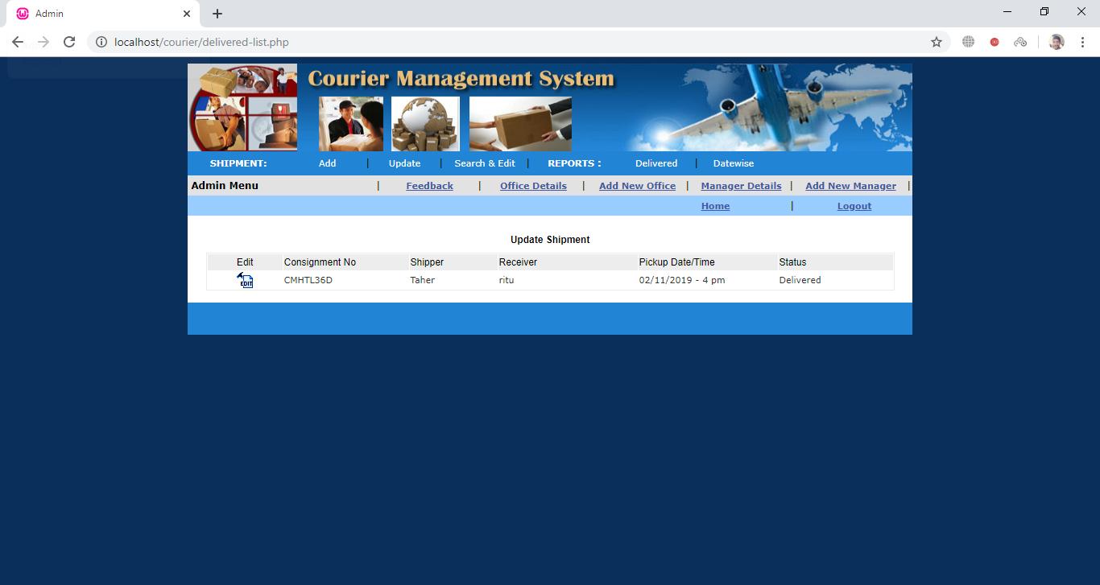

**Advantages**

* **You can find all the Courier office related information without Standing in queue in the Courier office.**
* **Manage the user details.**
* **Admin user can have facility to reduce the chances of the duplication of the data.**
* **Assured and speedy delivery of goods is possible.**
* **Addressee receives the parcel at the doorstep. He does not have to travel too far in search of his parcel.**
* **View various transactions.**
* **Parcel can be easily dispatched because the post offices are mostly near market places.**

**Disadvantages**

* **The main disadvantages of Courier management system is a admin support.**
* **Admin cannot book more then two Shipment simultaneously at a time for customer**
* **Maintenance cost of the system, wear tier of the system is very expensive**
* **It is not an online system, it is a standalone system.**
* **Due to standalone system admin have to collect the feedback from Customer manually.**
* **Report can be generated at the end of the day.**

**Future-Enhancement:**

* **Customer can book or use our services direct in our online portal in the next upcoming days.**
* **Customer can have the online particular id through which a customer can book or ship more than two parcel at a time**
* **And the delivery boy can pick the parcel from the doorstep.**
* **Feedback can be provided by customer on our online portal directly.**

**Bibliography**

* The information or whatever the data's and codes for the project are gathered and assembled from the various area and fields.
* The Google browser:
* Danni web.
* code forums.
* StackOverflow
* GeeksforGeeks.com
* References book:
* Learning PHP, MySQL, JavaScript, CSS & HTML5: A Step-by-Step Guide to Creating Dynamic Websites
* Author: Robin Nixon
* Publisher: Microsoft press
* SQL The Complete Reference” 3rd edition
* Authors: Weinberg,paul ; Groff, James ; Oppel, Andy
* Publisher: Pearson 3rd Edition